**DOCUMENTAÇÃO DE INSTALAÇÃO OCR-SERVER NO UBUNTU SERVER 14.04.5 LTS**

**Na instalação do Ubuntu Server marque as seguintes opções:**

* **Atualizar o Ubuntu:**

**aptitude update && aptitude upgrade -y && aptitude update && aptitude dist-upgrade -y**

* 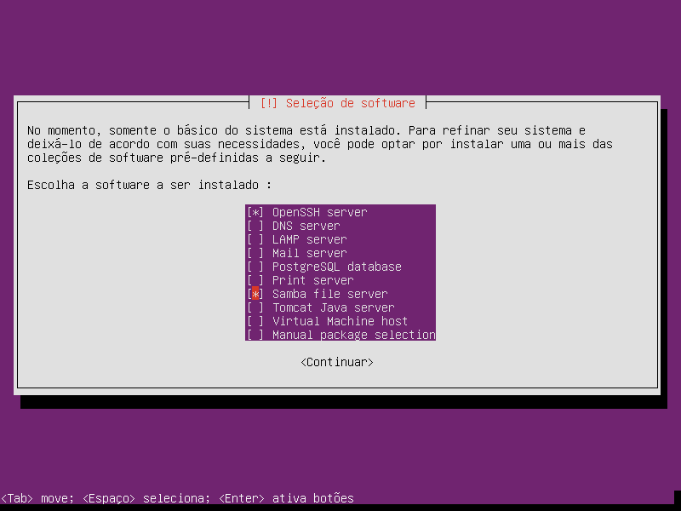**Criando a pasta que recebera os arquivos de instalação:**

**mkdir /Share && chown nobody -R /Share && chmod 755 -R /Share**

* **Limpar comentários do arquivo de configuração do samba e editá-lo:**

**mv /etc/samba/smb.conf /etc/samba/smb_orig.conf && grep -o '^[^#]*' /etc/samba/smb_orig.conf > /etc/samba/smb.conf && vim /etc/samba/smb.conf**

**Ao final do arquivo adicione:**

**[Share]**

**comment = Compartilhamento**

**path = /Share**

**browseable = yes**

**read only = no**

**guest ok = yes**

* **Execute:**

**smbd -s --configfile=/etc/samba/smb.conf**

**INSTALANDO OS PRÉ-REQUISITOS DO PERL:**

* **Execute:**

**cpan install File::Touch module File::Find::Rule File::Basename File::Copy File::Path File::Touch Sys::Syslog Sys::Hostname IPC::Open3 IO::Select POSIX**

* **Instale os seguintes recursos:**

**aptitude install g++ autoconf automake libtool autoconf-archive pkg-config libpng-dev libjpeg8-dev libtiff5-dev zlib1g-dev libicu-dev libpango1.0-dev libcairo2-dev libpng12-dev libjpeg62-dev libtiff4-dev zip unzip build-essential cmake libtool yasm pkg-config subversion git libgcj14** **libtiff-dev libpng-dev libopenjpeg-dev libjpeg8-dev libjpeg-turbo8-dev libjpeg-dev libgif-dev zlib1g-dev libicu-dev libpango1.0-dev libcairo2-dev libfontconfig1-dev libgettextpo-dev libcurl-dev libnss3-dev ocaml libgcj gcj-jdk -y**

**aptitude install libfile-find-rule-perl libfile-find-rule-perl-perl libtiff5 libpng12-0 libopenjpeg2 libjpeg-turbo8 libgif4 zlib1g libicu52 libpango1.0-0 libcairo2 fontconfig imagemagick gettext libwebp5 libgcj14 libtiff5 libpng12-0 libopenjpeg2 libjpeg8 libjpeg-turbo8 libjpeg8 zlib1g libpango1.0-0 libcairo2 libfontconfig1 libgettextpo0** **ghostscript sysv-rc-conf -y**

**apt-get remove ghostscript -y**

* **Copie a pasta ocr-server para a pasta compartilhada Share**

**INSTALAÇÃO DOS PRÉ-REQUSITOS**

* **Ghostscript**

**cd /Share/ocr-server/pre-requisitos/ghostscript-9.22**

**./autogen.sh**

**make && make install**

* **Cpdf**

**cd ../cpdf/pre-requisitos/findlib-1.7.3**

**./configure &&** **make && make install**

**cd ../camlpdf-2.2.1**

**make && make install**

**cp /Share/ocr-server/ocr-server.git/usr/local/bin/cpdf** **/usr/local/bin/cpdf**

**chmod 777 -R /usr/local/bin/cpdf**

* **Instalando o pdftk:**

**cd /Share/ocr-server/pre-requisitos/pdftk-2.02-dist/pdftk**

**make all -f Makefile.Debian && make install -f Makefile.Debian**

* **Instalando o poppler-utils:**

**cd ../../poppler-0.42.0**

**./configure && make && make install**

* **Instalando o tesseract:**

**cd ../tesseract/leptonica/pre-requisitos/plotlib-1.2/src**

**make all && make install**

**cd ../prog**

**make all && make install**

**cd /Share/ocr-server/pre-requisitos/tesseract/leptonica/leptonica-1.74.4**

**./configure && make && make install**

**cd ../../tesseract-master**

**./autogen.sh && ./configure && make && make install**

**cp /Share/ocr-server/pre-requisitos/tesseract/tesseract-master/tessdata/****eng.traineddata /usr/local/share/tessdata/eng.traineddata && cp /Share/ocr-server/pre-requisitos/tesseract/tesseract-master/tessdata/por.traineddata /usr/local/share/tessdata/por.traineddata && cp /Share/ocr-server/pre-requisitos/tesseract/tesseract-master/tessdata/equ.traineddata /usr/local/share/tessdata/equ.traineddata && cp /Share/ocr-server/pre-requisitos/tesseract/tesseract-master/tessdata/osd.traineddata /usr/local/share/tessdata/osd.traineddata**

**/sbin/ldconfig**

* **Instalando o OCR**

**cp /Share/ocr-server/ocr-server.git/usr/local/bin/ocr /usr/local/bin/ocr && cp /Share/ocr-server/ocr-server.git/etc/init.d/ocr-ubuntu /etc/init.d/ocr && mkdir -p /var/ocr-server/Entrada && mkdir -p /var/ocr-server/Erro && mkdir -p /var/ocr-server/Originais_Processados && mkdir -p /var/ocr-server/Saida && chown nobody -R /var/ocr-server/Entrada && chmod 777 /var/ocr-server/Entrada && chown nobody -R /var/ocr-server/Originais_Processados && chmod 777 /var/ocr-server/Originais_Processados && chown nobody -R /var/ocr-server/Erro && chmod 777 /var/ocr-server/Erro && chown nobody -R /var/ocr-server/Saida && chmod 777 /var/ocr-server/Saida**

* **Edite o arquivo /etc/samba/smb.conf**

**vim /etc/samba/smb.conf**

**[Entrada]**

**path = /var/ocr-server/Entrada**

**browseable = yes**

**read only = no**

**guest ok = yes**

**[Saida]**

**path = /var/ocr-server/Saida**

**browseable = yes**

**read only = no**

**guest ok = yes**

**[Originais Processados]**

**path = /var/ocr-server/Originais_Processados**

**browseable = yes**

**read only = no**

**guest ok = yes**

**[Erro]**

**path = /var/ocr-server/Erro**

**browseable = yes**

**read only = no**

**guest ok = yes**

* **Agora execute:**

**smbd -s --configfile=/etc/samba/smb.conf**

* **Habilitando na Inicialização do Sistema**

**sysv-rc-conf**

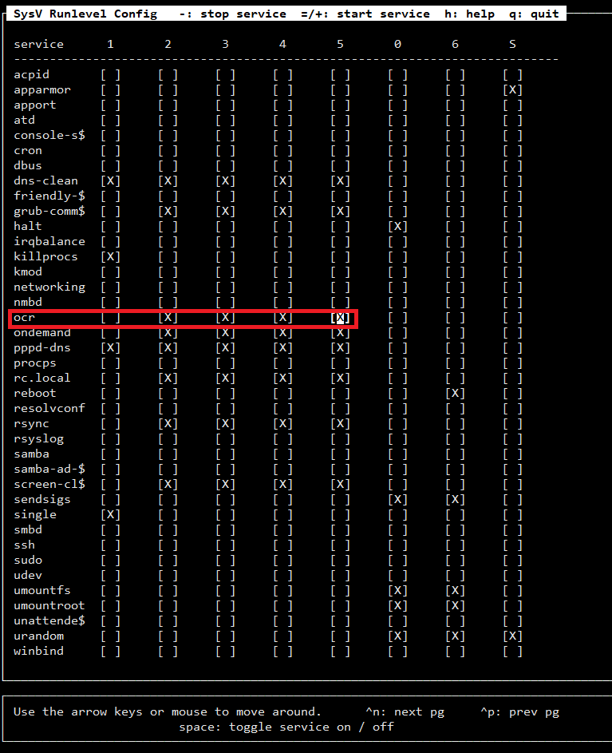

**AGORA REINICIE O COMPUTADOR:**

**reboot**